

Student Number: **202236159**

# Component One: Review of Articles

## Abstract

This report provides a synopsis of the impact and use of artificial intelligence for different medical purposes in a clinical environment; intelligent agents are used in telemedicine, mobility, surgery, rehabilitation, patient monitoring and for ultrasound purposes.

## Introduction

The intelligent agents are algorithms or software program that can be used to perform some specific functions or tasks unconventionally or without human interaction based on the intelligent agent’s understanding of their environment. The intelligent agents are built to work in dynamic and complex environment; they are usually developed through machine learning or artificial intelligence technologies. These agents can perform tasks ranging from data analysis, automation of process and decision making and they can also interact with other agents or human (Velibor Bozic, 2023).

## Aims

The intelligent agents are used for various purposes in a hospital environment to improve care giving to patient, optimize utilization of resources and improving the efficiency of the hospital operation and processes. Some other functions or usage of the intelligent agent in the hospital include monitoring of patient vital signs, identification of potential risks as well as patient medical history. Intelligent also are also used int the area of allocation of resources such as hospital bed allocation, manage and allocate staff based on specific needs in the hospital and medical equipment in real time. This process helps in reducing time wasting and effective use of hospital resources (Velibor Bozic, 2023).

Some technical and decision-making process are made easy using intelligent agents in clinical decision making through data analysis and also in engaging the patient to provide alternative support for the patient such as in answering patients’ questions, patient health status feedback, medication alert and much more all in the bid to promote healthcare delivery and improve overall healthcare outcome.

The use and adoption of novel technologies such as the use of robotics in healthcare environment has increased since the advent of covid-19 pandemic; this is meant to help in assisting in delivery of healthcare in some peculiar situations. This is so much important for the fact that vacancies for healthcare workers soared and the restriction on social activities hindered the traditional healthcare delivery system. Robots are capable of alleviating the pressure on the workforce, such is the use of remote presence robots that conduct virtual consultation as well as the robot that aids in the delivery of medical equipment in the hospital environment (Suleiman, T.A., Adinoyi, A. 2023).

## Contributions

Robots are used in the hospital environment as exoskeletons that aid the mobility of patients that suffered stroke. Robots are also used in performing remote surgical operation

Some of the application of Robots in healthcare includes:

* Surgical operation
* Mobility and Rehabilitation
* Radiotherapy
* Telepresence
* Pharmacy
* Imaging
* Delivery and transport.

Robotic Therapy

The Robotic HIFU is a potential treatment for many different conditions, but there aren't many commercially available devices. This study analyses the new robot-assisted HIFU systems, highlighting their competitive advantages and potential uses, as well as examining image guiding and feedback mechanisms, robotic positioning systems, and robotic positioning systems. Additionally, it looks for novelties offered by each system that enhance localised treatment and broaden the range of HIFU procedure feasibility. One element of interest is motion compensation, such as respiratory motion compensation. (Anthony, G, Rudy, M, Ashish R, Yue Chen et al.2023).

Breast Urological Robot

The focal ultrasound robots called RoBOTs were created for neuro, urological, and breast surgery. They cover a wide range of tumour types, and their application-specific robotic manipulator and kinematics complement this. A thermistor sensor module is used to record temperature measurements, giving closed-loop feedback control of the HIFU dose. The HIFU transducer's acoustic power may be modified by control algorithms in response to tissue reflections. A maximum positioning inaccuracy of 0.5 mm is achieved using the FUSBOT control algorithms. Trans-abdominal tumours may also be accessible with the FUSBOT because to additional jig axes and adjustable end-effectors (Anthony, G, Rudy, M, Ashish R, Yue Chen et al.2023).

AI agent Operating in Sophisticated Environment

Artificial intelligence is a significant idea with enormous potential for system optimisation, boosting industrial operations' productivity, upgrading healthcare platforms, and improving cellular technologies and connection. AI may be utilised to better healthcare platforms, increase productivity in industrial settings, and improve cellular technologies and communication. It can also be used to allay concerns that the growing usage of wireless technology would clog up the channels for communication between smart devices. Network slicing is a well-known usage of network intelligence in 5G to improve network performance. 5G networks may be used to incorporate machine learning (ML) and AI into the network edge (Suleiman, T.A., Adinoyi, A. 2023).

## Limitations

Given the large dataset that is available and required to be analyzed in this subject matter, there lies the risk of missing out on some relevant research studies, these could include the use of robots in healthcare that might not have been captured or identified.

There are risks associated with the smart healthcare system aside from natural disaster such as flood and earthquake; one of the most important risks is the fact that the technologies that are used in smart healthcare have their challenges which privacy issue where personal data can easily find their way into third party hands. Patients’ location is constantly exposed due to tracking technology which can cause breach of security. The risks associated with this technology needs to be addressed (Suleiman, T.A., Adinoyi, A. 2023).

Privacy Risk

Privacy is a major risk with connected healthcare systems, such as video conferences and telemedicine sessions. Automated contact tracing tools can collect sensitive location data without the owner's knowledge, which can be used by third parties for advertising purposes.

## Future Contributions

The main focus of robotics in healthcare should be in the area of telepresence and in performing tasks that are usually associated with human agent; these should include surgery, disinfection of hospital environment as well as in more complex function such as helping patient regain mobility.

AI Diagnostic Tool should be designed in such a way to provide reliable and accurate diagnosis without human interference

Standardized data collection and analysis tool that can help in addressing issues of biases and incomplete dataset as well as ethical use of the AI generated data

# REFERENCES

* Velibor Bozic (2023) Using intelligent software agent in Hospital. Retrieved: <https://www.researchgate.net/publication/368882471_Using_intelligent_software_agents_in_hospital>
* Anthony, G, Rudy, M, Ashish R, Yue Chen et al. Review of Robot-Assisted HIFU Therapy. National Library of Medicine (2023). <https://www.ncbi.nlm.nih.gov/pmc/articles/PMC10098661/>
* Suleiman, T.A., Adinoyi, A. Telemedicine and Smart Healthcare -The Role of Artificial Intelligence, 5G, Cloud Services, and Other Enabling Technologies. Int.J. Communications, Network and System Sciences, 2023, 16, 31-51 (2023). <https://www.scirp.org/pdf/ijcns_2023032413443512.pdf>
* Morgan, A.A, Abdi, J, Syed, M.A.Q. et al. Robots in Healthcare: A Scoping Review. Current Robotics Reports 3, 271-280 (2022). <https://doi.org/10.1007/s43154-022-00095-4>
* Budd, J., Miller, B.S., Manning, E.M. et al. Digital technologies in publich -health response to Covid-19. Nat Med 26, 1183-1192 (2020). <https://doi.org/10.1038/s41591-020-1011-4>
* Ayesha, A. A Review on Innovation in Healthcare Sector (Telehealth) through Artificial Intelligence (2023). <https://www.researchgate.net/publication/370028893_A_Review_on_Innovation_in_Healthcare_Sector_Telehealth_through_Artificial_Intelligence>

# Component Two:

## 2a) Combination of Variables that best predict Global Sales

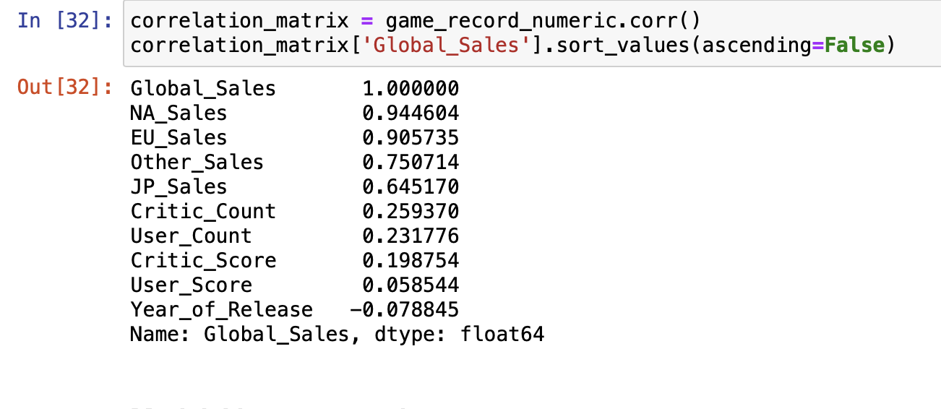

Figure 1: Correlation Matrix in ascending order

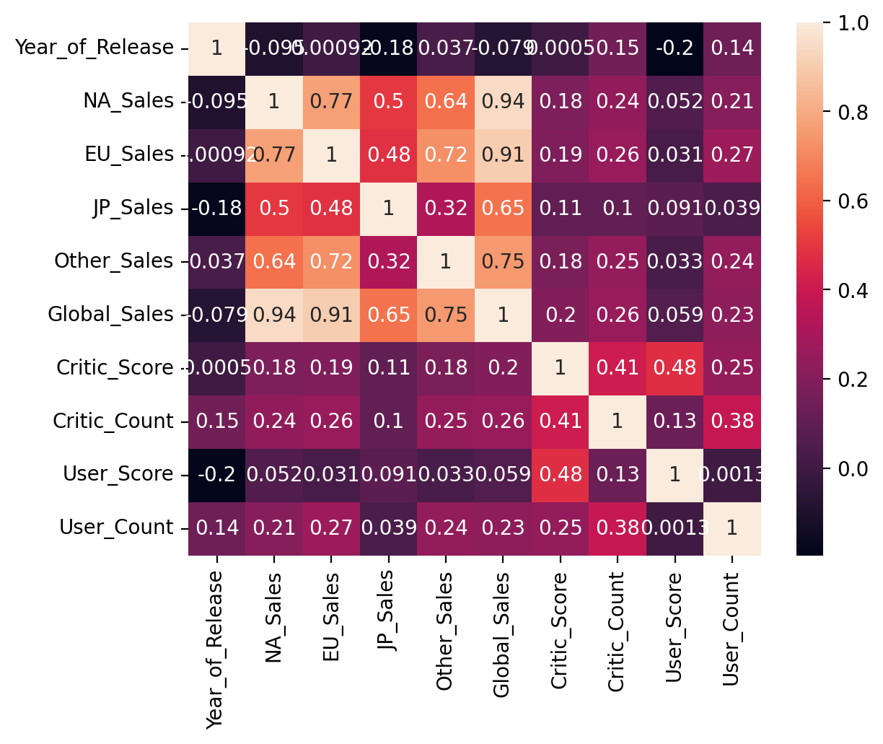

Figure 2: Correlation Heatmap

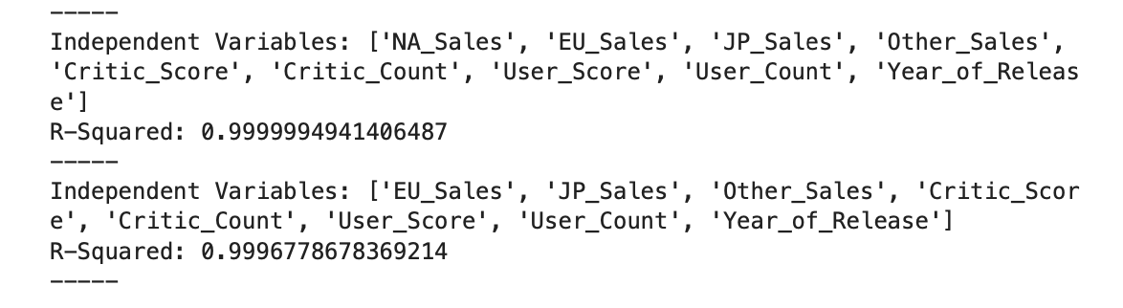

Figure 3: R-Squared Score of Variables combination with Decision Tree Regressor

Using Global Sales as the dependent variable, decision tree regressor provide the best result of the combination of the variable that best predict Global Sales. The above figure 1 and 2 is the correlation matrix for all the features in the game record data frame, and then sorts the correlation coefficients in descending order to see which features are most strongly correlated with the "Global Sales" variable. This give an insight of which of the variables would be a better predictor.

From figure 3 above, the best variables combination is NA_Sales, EU_Sales, JP_Sales, Other Sales, Critic Score, Critic Count, User Score, User Count and Year_of_Release which produce a R-Squared score of 0.9999994941406487.

The model above uses the testing sets to predict and then calculate the R-squared score as quantitative measures for the model performance to determine which variables are the most important for Global sales prediction.

## 2b) The effect that number of Critic, Users and review score will have on North America, EU and Japan Sales

The effect of the number of critics, users and user review score on North America, EU and Japan video game sales is as represented in from the output of the models as indicated below. The multiple linear regression clearly outperform the Decision Tree Regression based on their output. The root mean squared error (rmse) for the North American sales is 1.1279 which shows that the sales in that region has an error average of 1.13 million units while the Root Squared score for North America is 0.0538 which means that the model has variance of 5.38% in the sales of North America.

The root mean squared error (rmse) for EU is 0.7601 which shows an average error of about 760,000 units and with a Root Squared score of 0.0648 which translate to the model having 6.48% variance of sales in the EU region.

The Japanese sales has a root mean square error (rmse) of 0.316 that shows that the average error in that region is 316, 000 units with a Root Squared score of 0.0294 which translate to a 2.94% variance in Japanese sales.

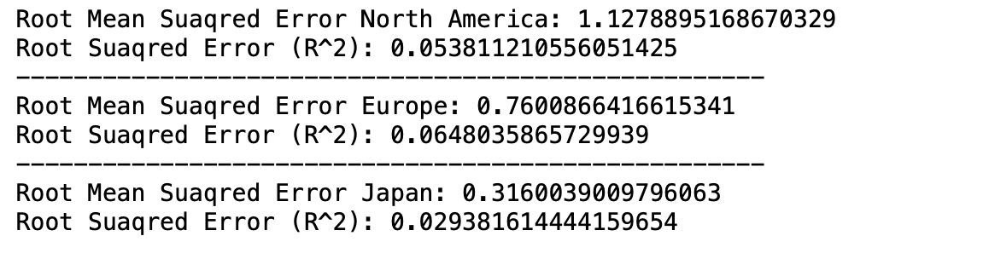

Figure 4: Using Multiple Linear regression

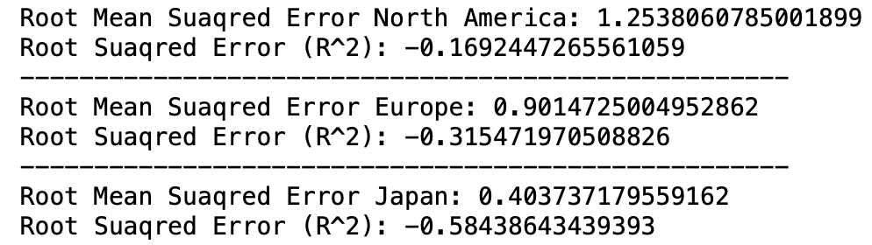

Figure 5: Using Decision Tree

From the explanation above, it showed that the number of critics, user score, user review score does not have a strong sales predictive relationship with the sales of video games in the regions. Other factors may play an important role in the sales of video games in that region such as platforms, developer or marketing strength.

## 2c) Reason for the choice of regressor

From figures 4 and 5 respectively, the result of the models suggests that multiple linear regressor performs better than the decision tree model as can be seen from the result of the Root Square Score of North America 0.0538, EU 0.0648, Japan 0.0294 as compared to the decision tree which shows high root mean square error (NA 1.2538, EU 0.9015, Japan 0.403) but with a negative Root Squared Score for each of the tree regions (North America -0.1692, EU -0.3155, Japan -0.5844).

Summarily, the choice of linear regressor is based on the fact that it does a better prediction and it is a better fit for the data as shown in the values of the root mean square error and a higher Root Square scores as against the decision tree that used to compare the result.

## 2d) Using all relevant categorical variables as the target to determine which of the variables perform best in classifying the dataset

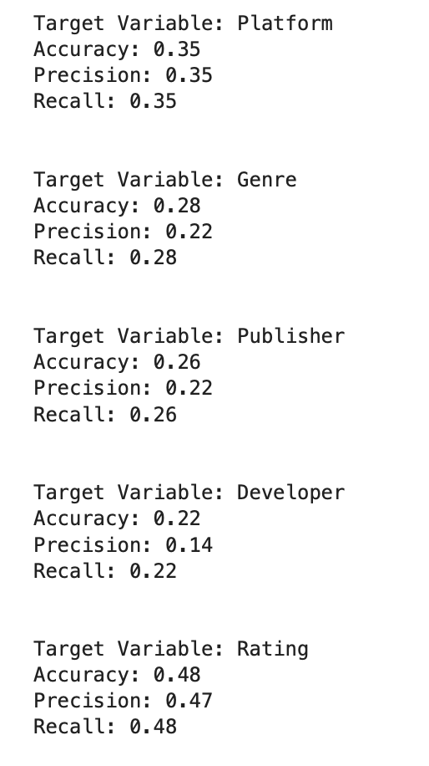

Figure 6: Classification

Having used all relevant categorical variables a target to determine which variable perform better in classifying the dataset, the result showed that the Rating variable perform better than the rest of the categorical variable and it is most reliable for predicting other categorical variables with the following result- Accuracy: 0.48, Precision: 0.47 and Recall: 0.48 scores. The Developer variable has the lowest predicting accuracy with a low precision, low accuracy and low recall scores (Accuracy: 0.22, Precision: 0.14, Recall: 0.22). The results is as shown in figure 6 above.

## 2e) Checking for overfitting

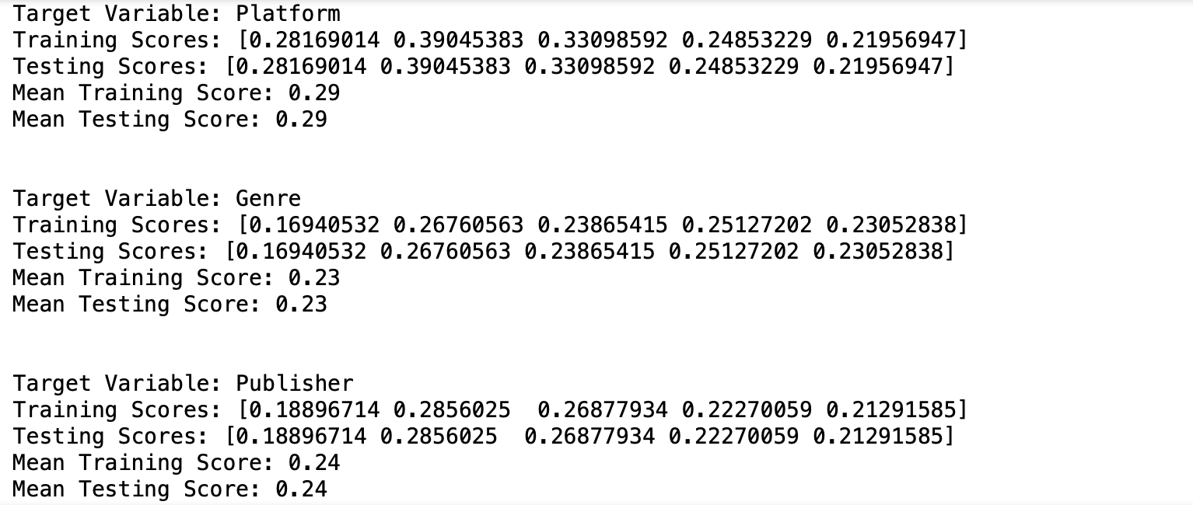

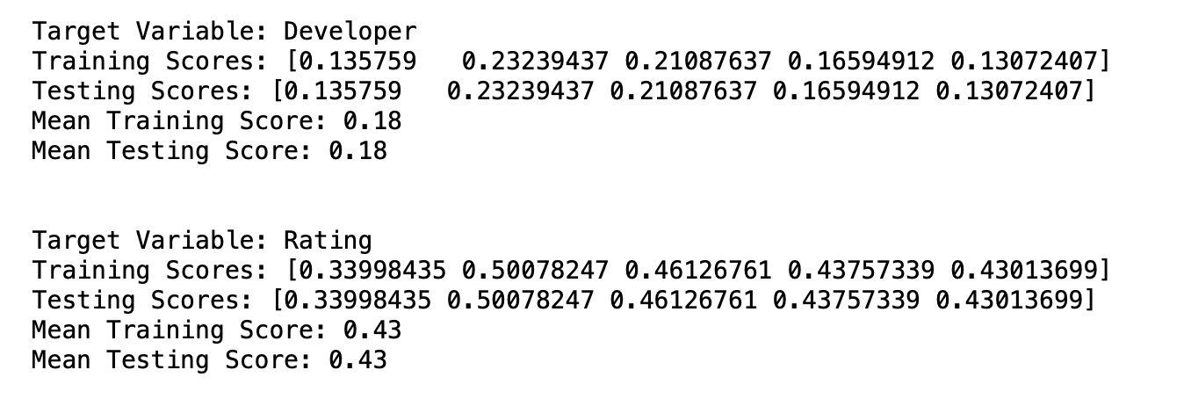

Figure 7: Checking Overfitting using cross validation scores

In order to check overfitting, the model is trained for each target variable which are Platform, Genre, Publisher, Developer and Rating using training dataset and testing dataset. The model performance is evaluated using accuracy score, the highest score represents the best performance.

The training score is the accuracy of the model when the model is trained while testing score is the model when the model is tested. The mean training score and the mean testing score for each target platform are the same as shown in the figure above.

Summary:

Based on the result above the model is not overfitting as a difference in training and testing score would have suggest overfitting and it is a good model based on the given data.

## 2f) Can the classification model be deployed in practice

The choice or decision for deploying a model should be solely based on the performance of that model in terms of its high accuracy score, high precision score and recall score. Based on the aforementioned criteria, the result of the model is not as high enough to guarantee its performance when deployed in practice. However, the model can be modified and or tuned to be ready for production environment.

## 2g) internal and external evaluation metrics to determine which categorical variable best describe the group formed.

Using a relevant categorical variable and other non-relevant categorical variables to form group. Using internal and external evaluation metrics to determine which categorical variable best describe the group formed

### Internal Evaluation Metrics

### Categorical Variable: Rating and Non-Categorical Variable: Critic Score

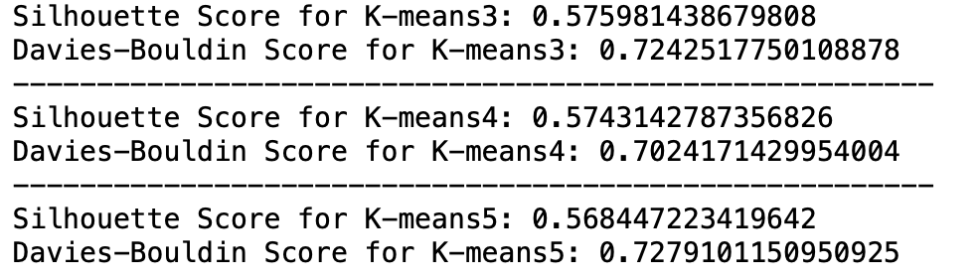

Figure 8: The use of Silhouette Coefficient and David-Bouldin Index Using different number of Clustering (n_clusters = [3, 4, 5]):

### Categorical Variable: Genre and Non-Categorical Variable: Critic Score

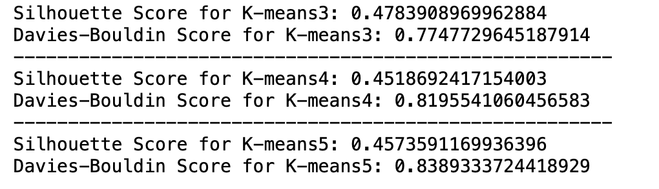

Figure 9 : The use of Silhouette Coefficient and David-Bouldin Index using different Number of Clustering: (n_clusters = [3, 4, 5]):

### Categorical Variable: Platform and Non-Categorical Variable: Critic Score

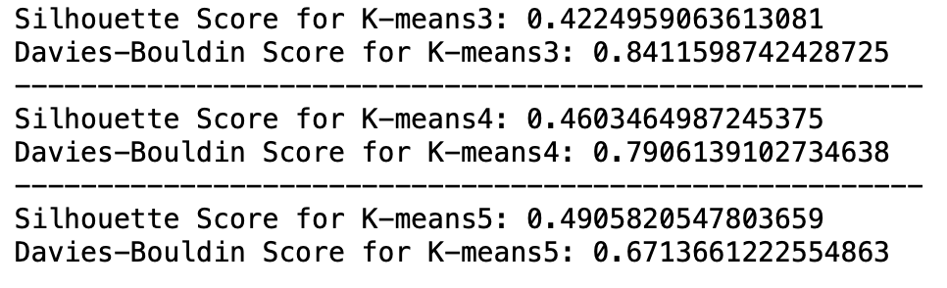

Figure 10: The use of Silhouette Coefficient and David-Bouldin Index Using different number of Clustering: (n_clusters = [3, 4, 5]):

The above result (figure 8) is from internal evaluation metrics that measures the quality of clustering algorithm used which are Silhouette score and Davies Boulding Score to evaluate K-mean clusters of 3, 4 and 5 respectively. The Silhouette score showed that the clusters are well defined; the Silhouette score of 0.576, 0.574 and 0.568 are relatively high which suggest that the data is well formed clustered. While Davies Bouldin Scores of 0.724, 0.702 and 0.728 indicate that the cluster are well separated.

The result shows that the clustering algorithm with categorical variable Rating and a non-categorical variable Critic Score performed well for all the three clusters but the best result is K-Means3 when the number of cluster (n_clusters =3).

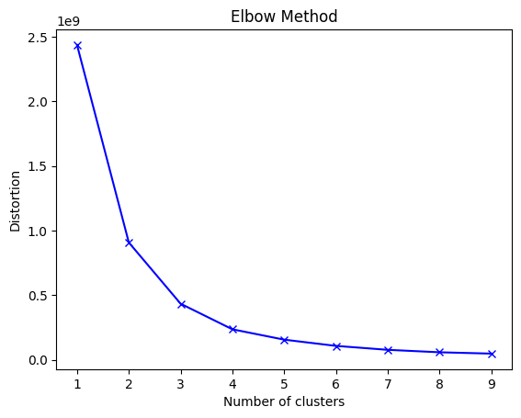

Figure 11

The result from other evaluation metrics using Platform and Critic Score (Silhouette Score of 0.422, 0.460 and 0.491 with Davies Bouldin Score of 0.841, 0.791, 0.671) as well as Genre and Critic Scores (Silhouette 0.478, 0.452 and 0.457 and Davies Bouldin score 0.775, 0.819 and 0.839) do not perform better compare to Rating as categorical variable and Critic Score as non-categorical variable.

Having compared the three results, Rating as Categorical variable and Critic Score is a better predictor of the group formed by the clustering algorithm using n_cluster of 3 which have the highest performance score and it can be seen in figure 11 above.

### External Evaluation Metrics

The use of Adjusted Rand index and Normalized Mutual Information Using different number

of Clustering

### External Evaluation Metrics - Rating

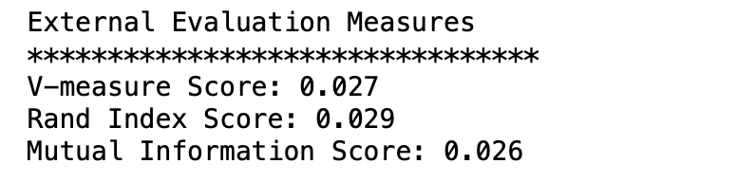

Figure 12

External Evaluation Metrics - Platform

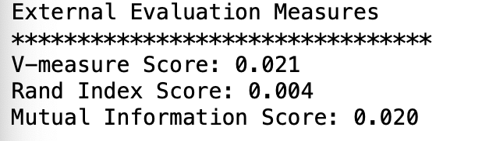

Figure 13

External Evaluation Metrics - Genre

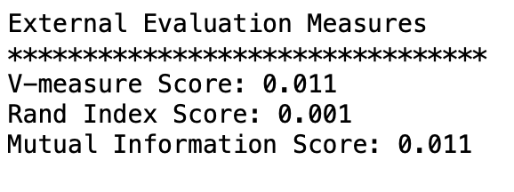

Figure 14

The result from figures 12, 13 and 14 shows the performance of external evaluation metrics using Rating, Genre and Platform as external true label respectively. External evaluation metrics V-measure, Rand Index Score and Mutual Information Score were used. The V-measure score which shows completeness and homogeneity of the clustering results compare to the external label range from 0 to 1 and the highest score of 0.027 – Rating, 0.021 – Platform and 0.011 – Genre is quite low which suggest that the algorithm did not perform well.

The Rand Index Score which measures the similarity between the clustering result and the external true label has the highest score of 0.029 which is very low and suggest that the algorithm did not perform well.

The Mutual Information Score which measures the mutual dependence of clustering results and external true label has the highest score of 0.026 which is also low and also show that the algorithm did not perform well and external evaluation metric cannot be relied on to determine true groups based on the external labels of Rating, Genre and Platform

# Component Three:

## 3a) How different regularisation methods affect the performance of CNN model

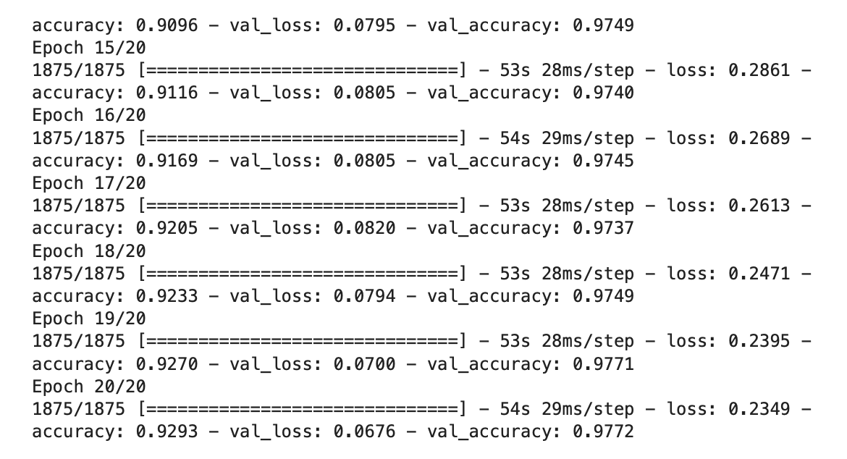

Figure 15

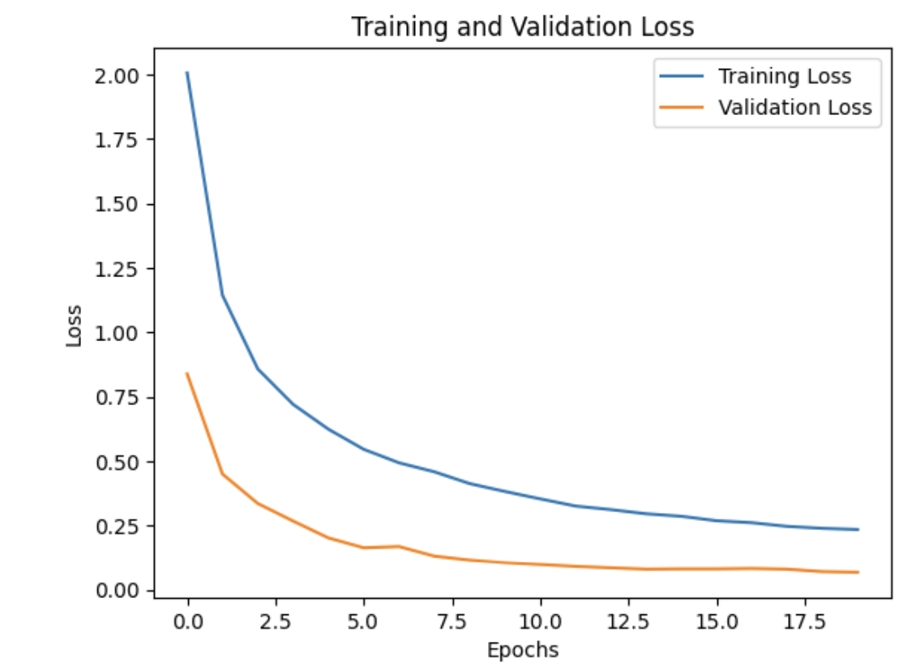

Figure 16

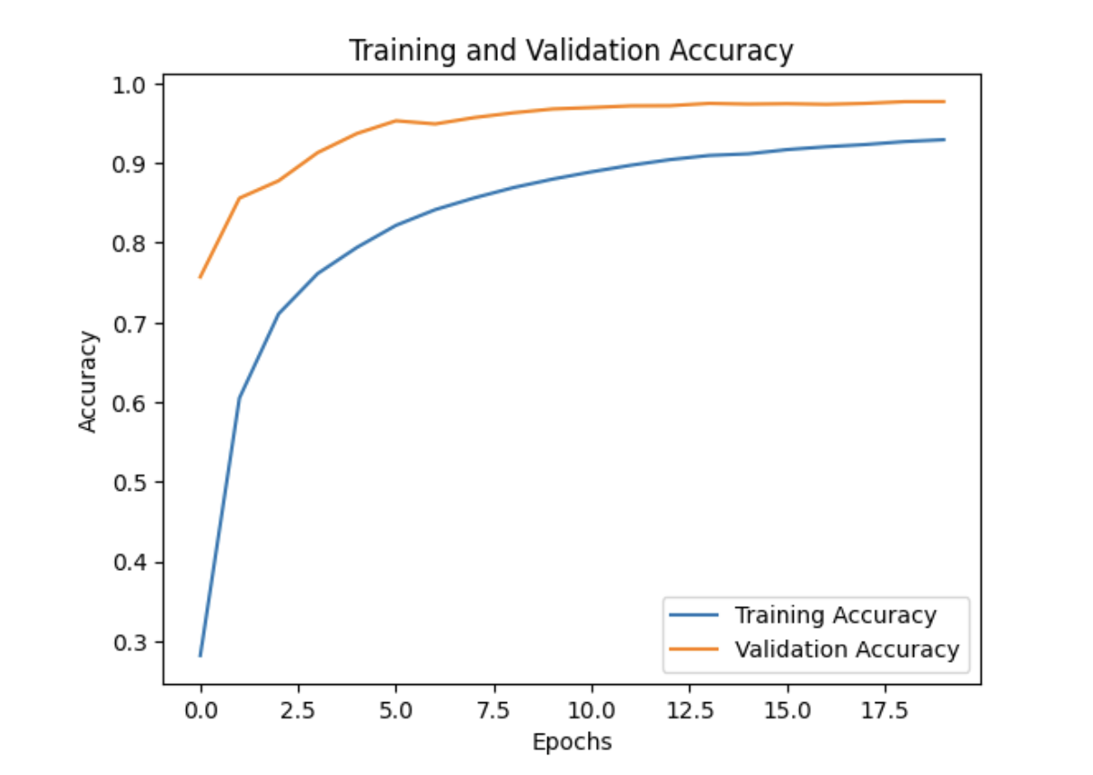

Figure 17

The figures (15, 16 and 17) above are the result of the convolution neural network model that is trained using 20 epochs on the MNIST dataset which is a handwritten digits between 0 and 9; the model is trained using different filters 32, 64 and 128 in its convolution layers. The results of the training and validation accuracy as well as loss for each of the epoch showed that the training accuracy starts from 0.2815 and it gradually improve with each of the epoch until it reaches the 20th epoch with a final training accuracy of 0.9293.

The training loss also continually decreased from 2.0053 from first epoch to 0.2349 at the 20th epoch.

The validation accuracy and loss also improve considerably through each epoch but not as compared to the training metrics. The result of the validation accuracy rose from 0.7571 and reached 0.9771 at the 20th epoch while the validation loss decreased from 0.8381 and it reached 0.0700 at the end of the 20 epochs

From the analysis above, the model has learned how to recognize handwritten digits with high degree of accuracy with a total validation accuracy of 97.71% at the end of the training.

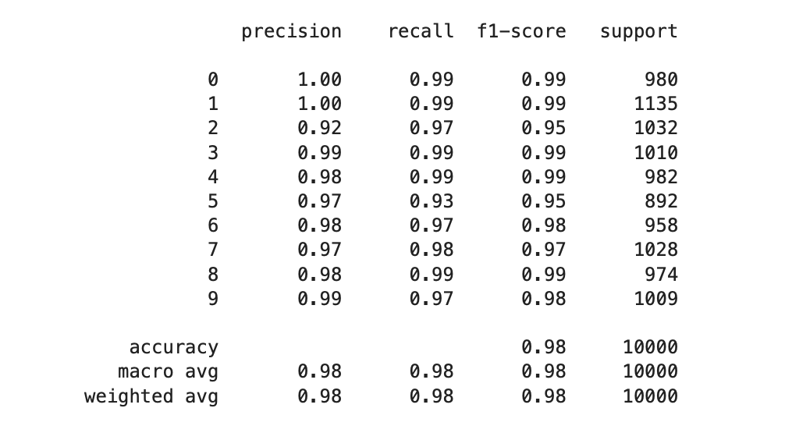

Figure 18

Figure 18 shows the result of the classification report of the performance of the model with a dataset of 10,000 samples. The precision is the measure of the number of samples that were predicted to be in a certain class were in the class actually, the Recall is the measure of the number of samples in a class that were actually predicted correctly by the model while the f1-score is the harmonic mean of the precision and the recall that gives a balanced measure of the performance of the model for each class.

The report in figure 17 showed that the model has a very high overall performance with 98% of model prediction accuracy. The precision, the recall and the f1-score also have high percentage score of 0.98 that showed that the model performed creditably well across all the classes in classifying handwritten digits dataset.

### Regularization Using Data Augmentation

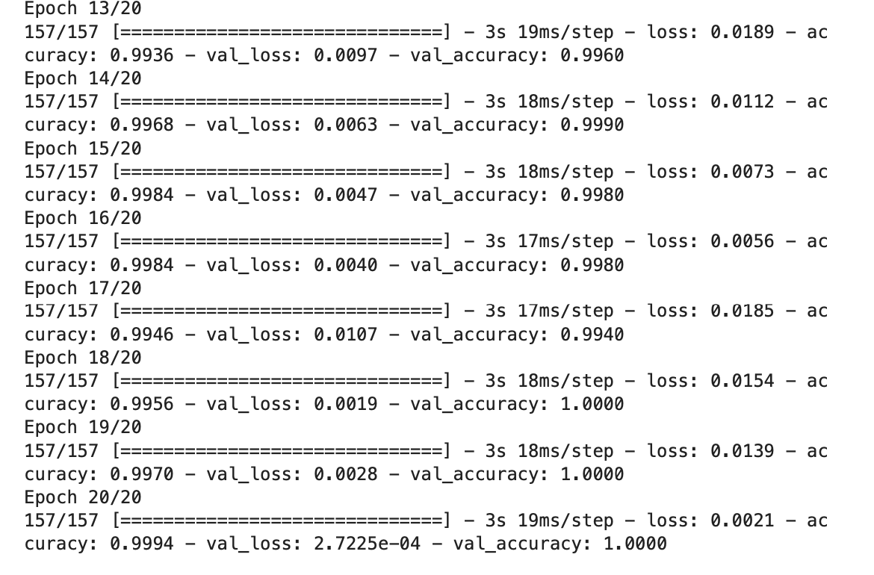

Figure 19

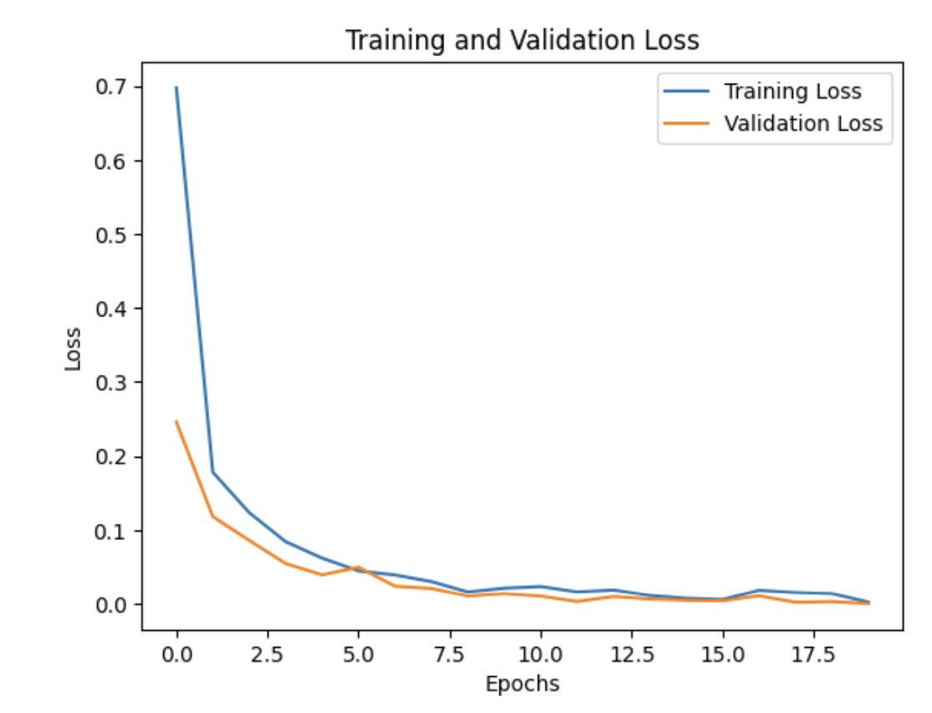

Figure 20

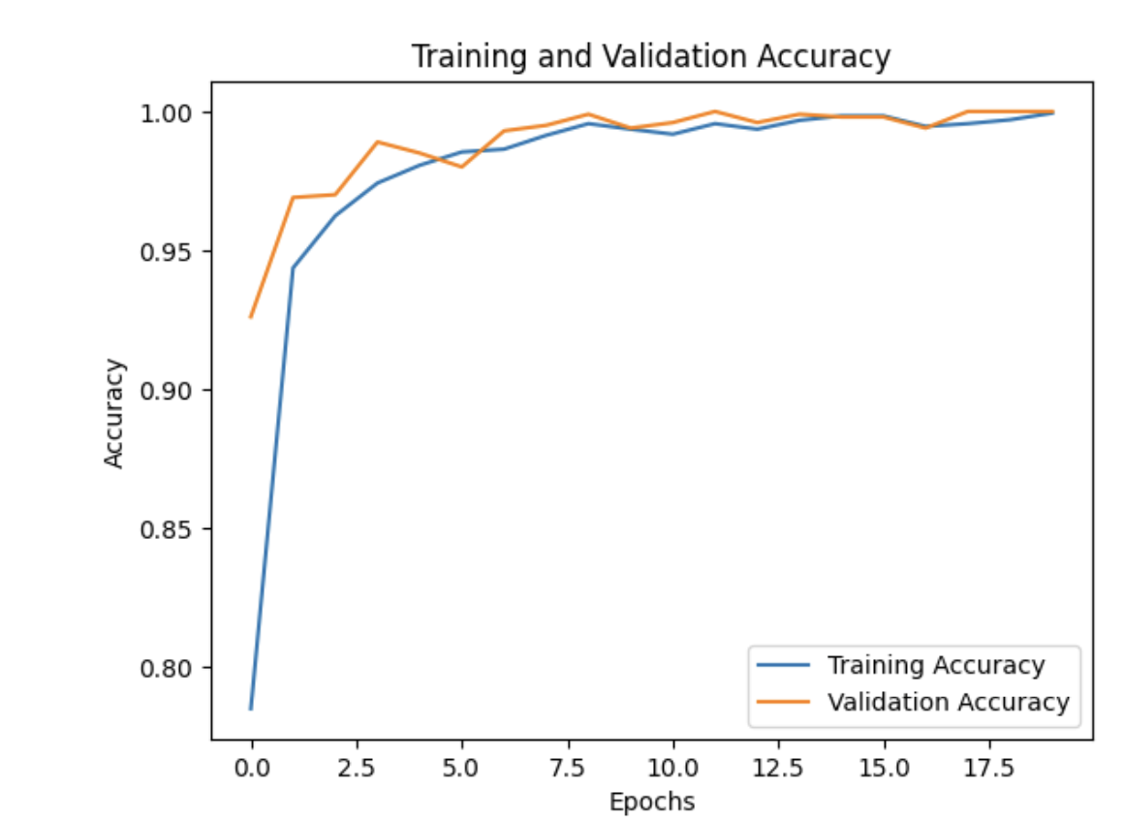

Figure 21

The figures (19, 20 and 21) above are the result of the convolution neural network model that is trained using 20 epochs on the MNIST dataset which is a handwritten digit between 0 and 9;

The result the model has high initial training loss and accuracy which showed that the model is not able to train or fit the given dataset very well but it classifies the dataset with good and relative high accuracy, as the training continues over 20 epochs, the training gradually reduces; an indication that the model improves over time.

The validation loss and validation accuracy also show the same trend with initial high validation loss which means that the model is not able to generalize well but the performance improves as the epoch increases and the validation loss reduce significantly while the validation accuracy increases and reached 100%. That means the model is able to generalized well and classify very well with high accuracy over 20 epochs.

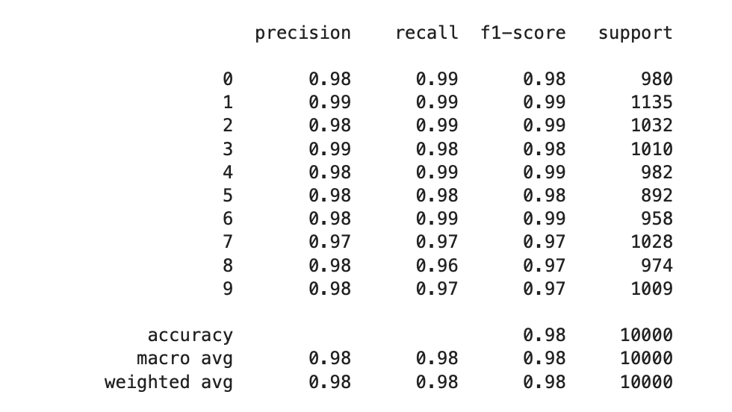

Figure 22

Figure 22 shows that the model has performed satisfactorily well with high precision, recall and f1-score for each of the digit class. The model is able to achieve a high precision of 0.99 and recall 0.99 for one digit which means all the prediction are actually correct. The precision, the recall and the f1-score also have high percentage score of 0.98 that showed that the model performed creditably well across all the classes in classifying handwritten digits dataset.

The overall model accuracy is very high with a value of 0.98 a result that showed that the model is able to classify with 98% accuracy

## Regularization Using Early Stopping

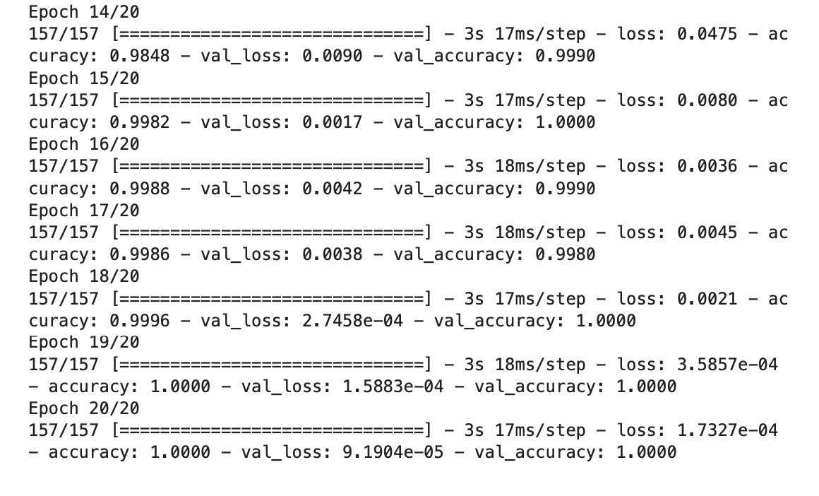

Figure 23

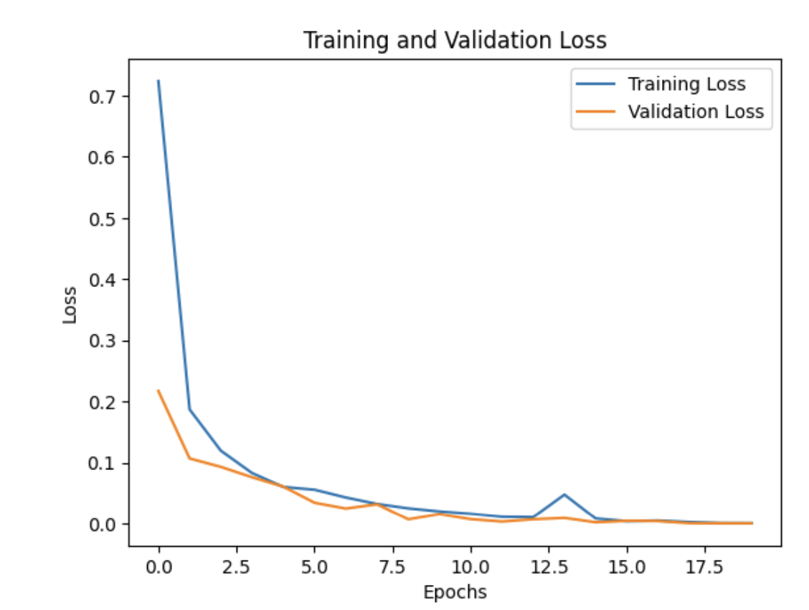

Figure 24

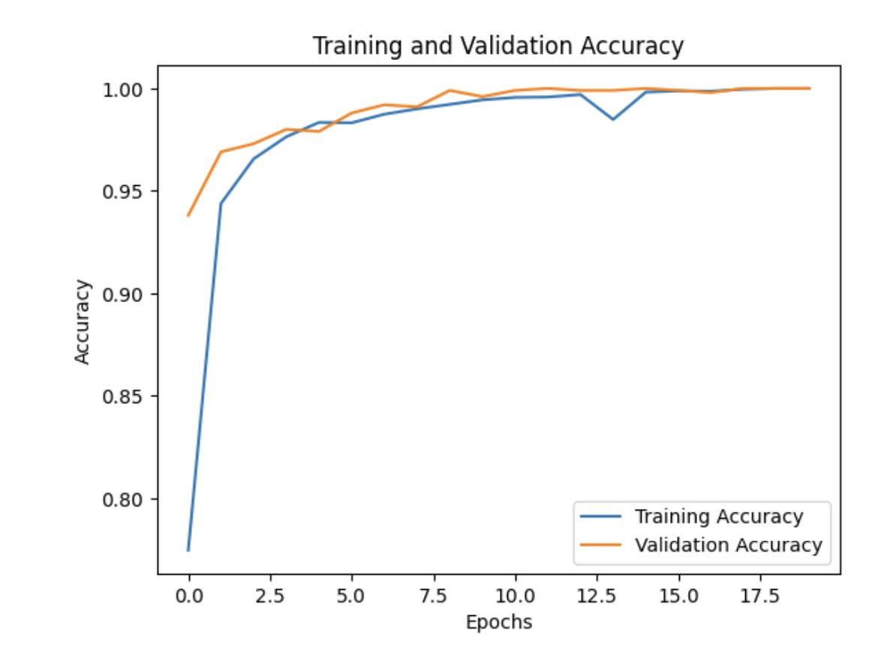

Figure 25

The result from the classification model over 20 epochs where the model is able to process the training dataset but with an initial high loss and low accuracy in terms of the training and validation datasets. As the training progresses, the result improved significantly which is an indication that the model is learning to make a more accurate prediction. The model has high training accuracy than validation accuracy as showed in the graph above.

This means that the model has started to overfit for the training data but the validation accuracy increases and the training progress over 20 epochs which means that the model is not overfitting severely.

At the end of the process, the model achieves a low loss and high accuracy for the training dataset and the validation dataset with a high validation accuracy of 100%. This showed that the model has learned well and it can make accurate prediction

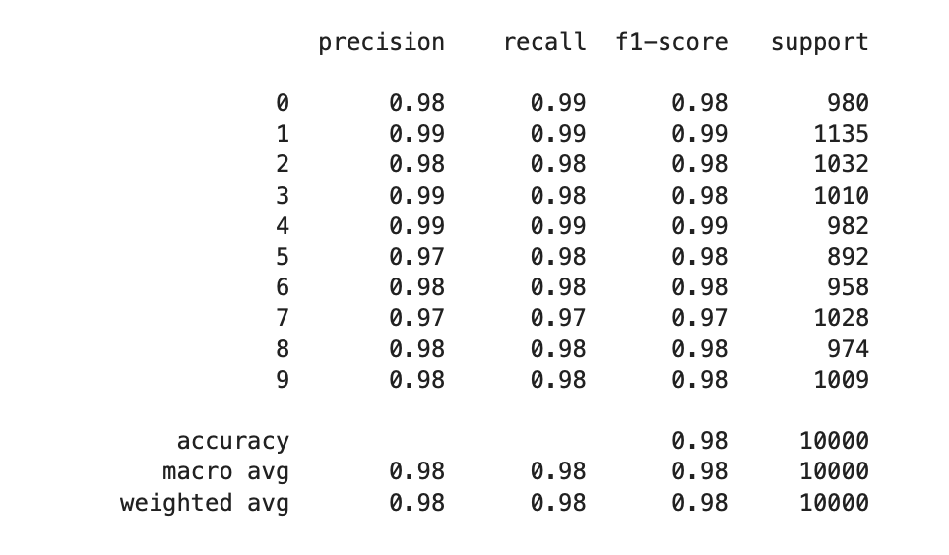

Figure 26

The overall performance of the model is very good with an accuracy of 98% which means the model is able to predict the digits for 98% of the images in the dataset. The precision, recall and f1-score for each of the class is 98%. Across the classes, the model performs well with scores ranging from 0.97 to 0.99.

In summary, the results suggest that the classification model has been trained successfully on the dataset and is able to accurately predict the handwritten digits with high precision, recall, and F1-score.

## 3b) How changes to the number of convolution blocks affect the performance of the model quantitatively

### Dropping One Convolution block (128) from the first model

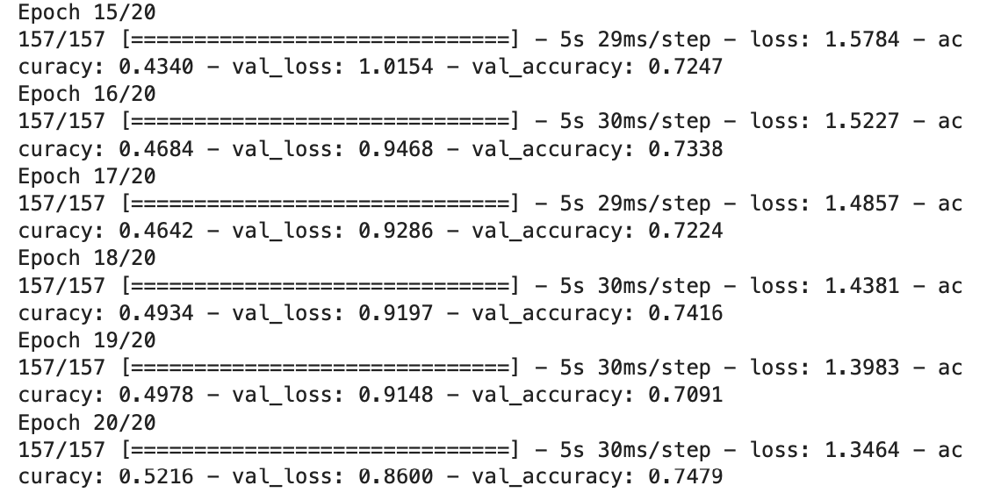

Figure 27

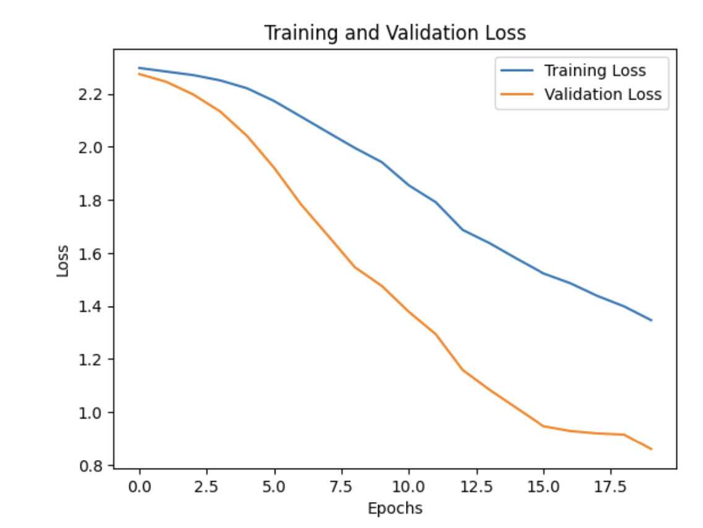

Figure 28

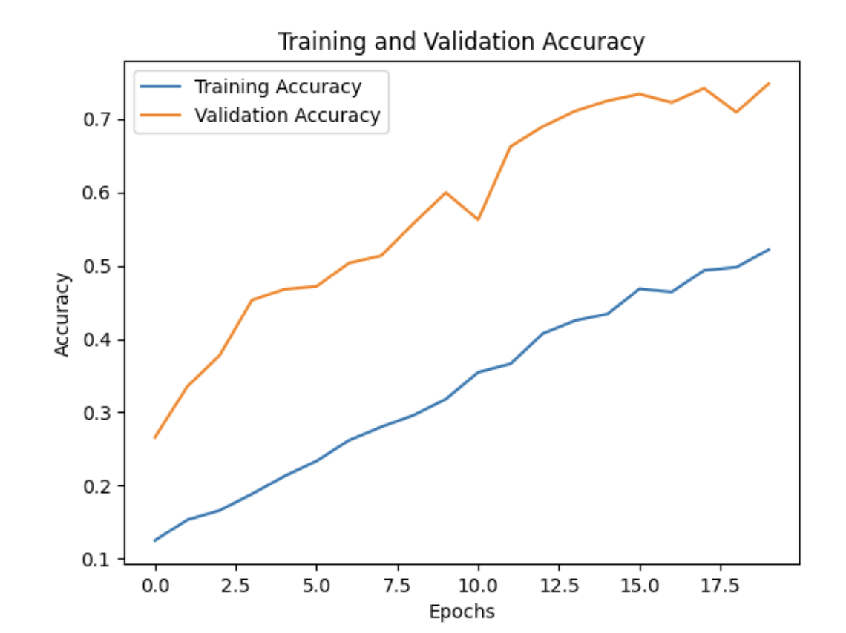

Figure 29

The result of the classification model with changes to the convolutional blocks by dropping one convolution block and filter 128. The following results as shown above. In the first epoch the training accuracy was very low 0.1248 while the validation accuracy is lower at 0.2660. This showed that the model is learning the features for performing the classification task yet. As the training continues, the model accuracy increases reaching 0.7479.

The changes to the convolution block, that is reducing the convolution block had led to a reduction in the overall accuracy of the model 75% as compared with the original 97.7% in figure 15 above.

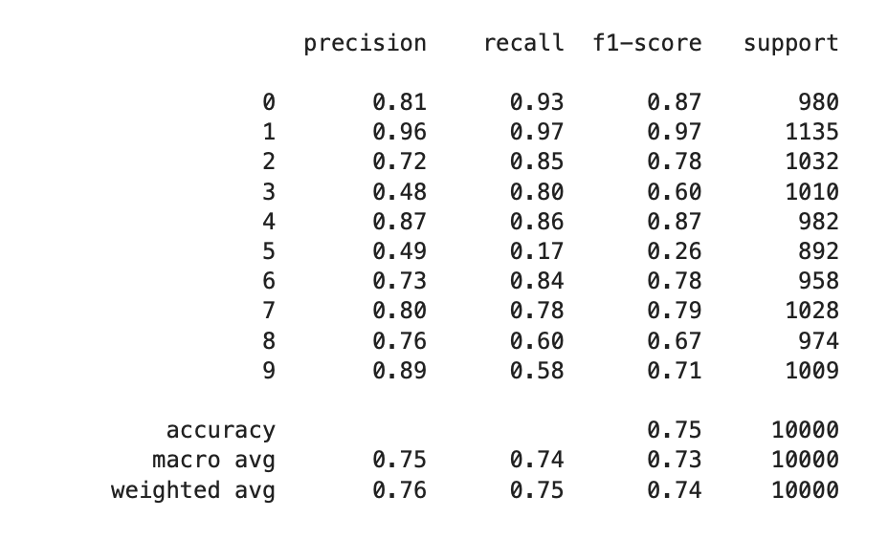

Figure 30

As a result of the dropping of the convolution block, there is a sharp reduction in the performance of the model with overall performance 0f 75% in figure 30 as compared to the result in figure 18 with an overall accuracy of 98%.

### The model performs well for certain classes but not so well for others, as can be seen from the precision and recall scores for each class. For classes 1, 4, and 9, it performs well, attaining precision and recall scores above 0.85. The model struggles to correctly identify several samples from classes 3 and 5, as evidenced by the low recall scores for these classes. The precision score for class 5 is also poor, indicating that the model frequently forecasts this class inaccurately.

### Adding One Convolution block (128) to the second model

Regularization Using Data Augmentation

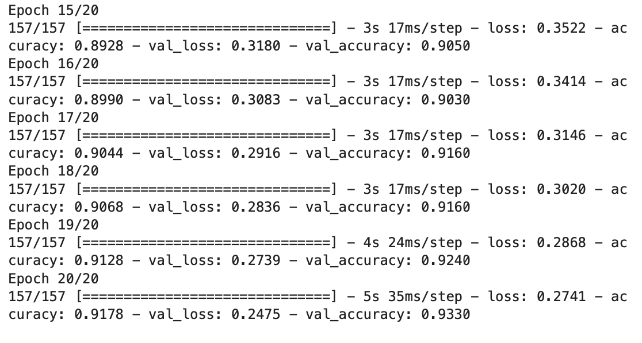

Figure 31

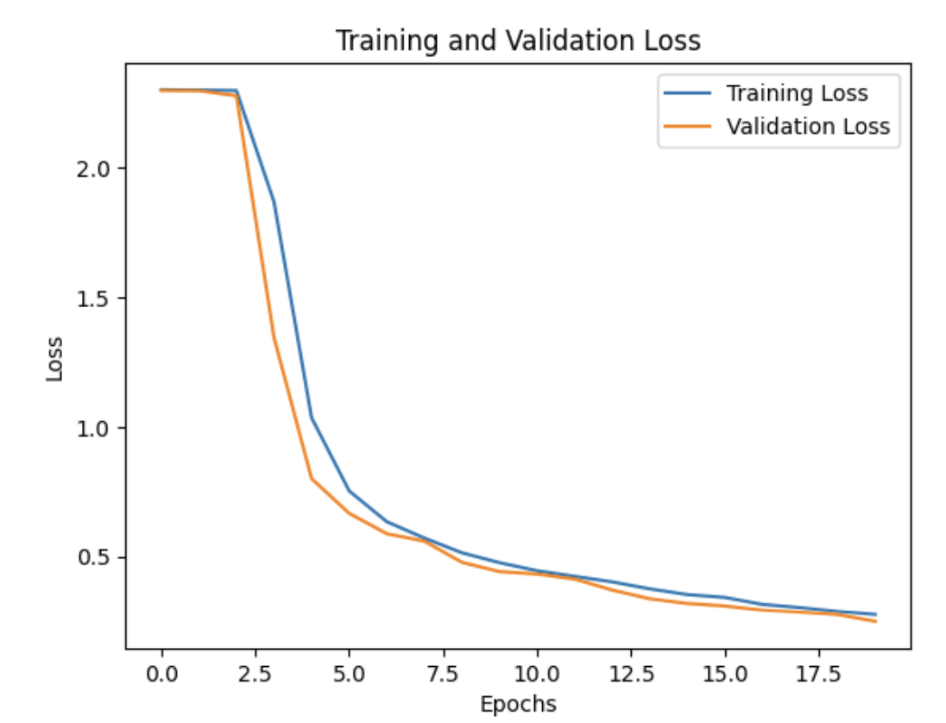

Figure 32

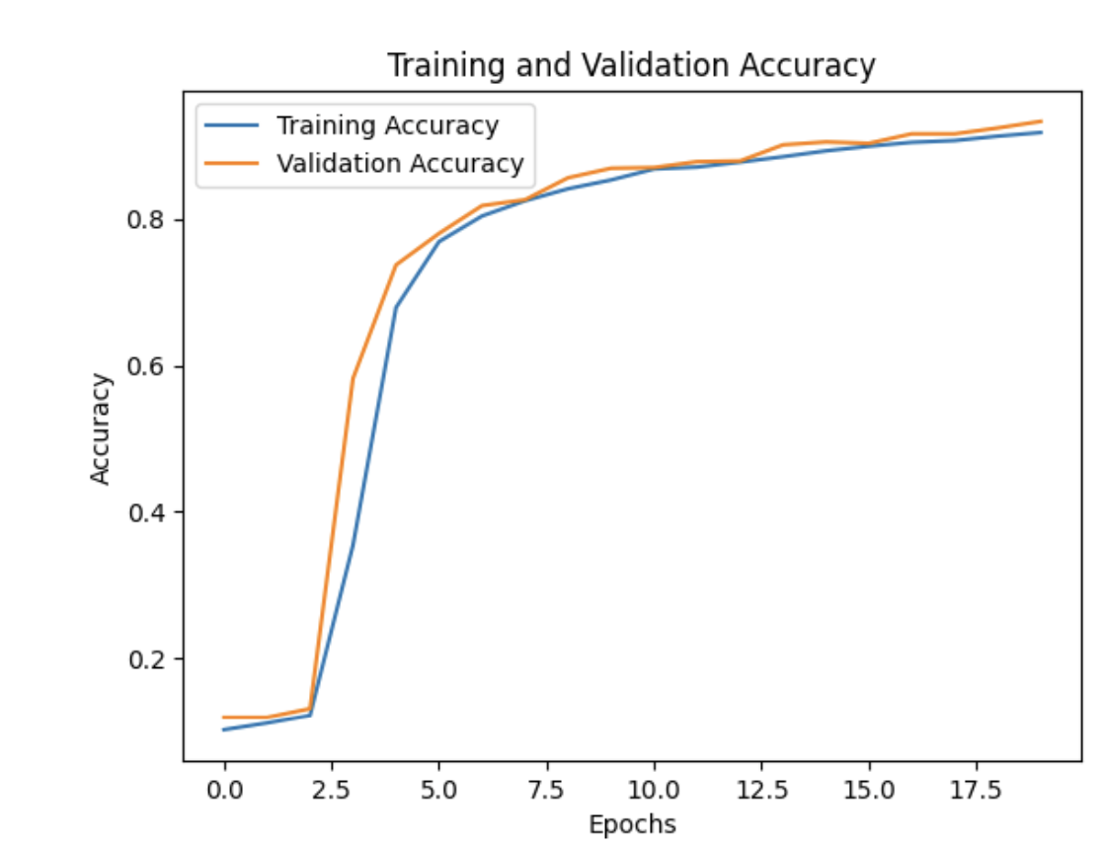

Figure 33

With each epoch, the validation accuracy gradually improves, showing that the model is getting better at generalization. The model's accuracy on the training data and the validation data at the end of training is 91.78% and 93.30%, respectively. When the validation accuracy exceeds the training accuracy, the model is not overfitting and is effectively generalizing to new data.

Overall, the outcome indicates that regularisation with data augmentation is a useful method for enhancing deep learning model performance.

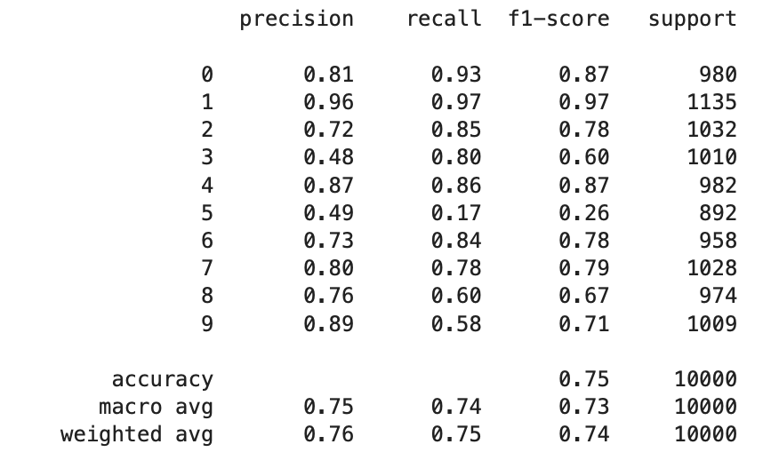

Figure 34

The weighted average takes into account the number of samples in each class, whereas the macro average of the evaluation metrics computes the average of the metrics across all classes. The model's macro average F1-score is 0.73, which indicates that it performs relatively well on average across all classes. The weighted average F1-score is significantly lower, at 0.74, showing that classes with more samples and larger support have a stronger impact on the model's performance.

The model's overall accuracy is 0.75, which indicates that 75% of the test set's samples were properly identified.

# Question 3c

## What is the effect of varying learning rates on the performance of the CNN algorithm.

Learning Rate: **=** [0.001, 0.01, 0.1, 1.0]

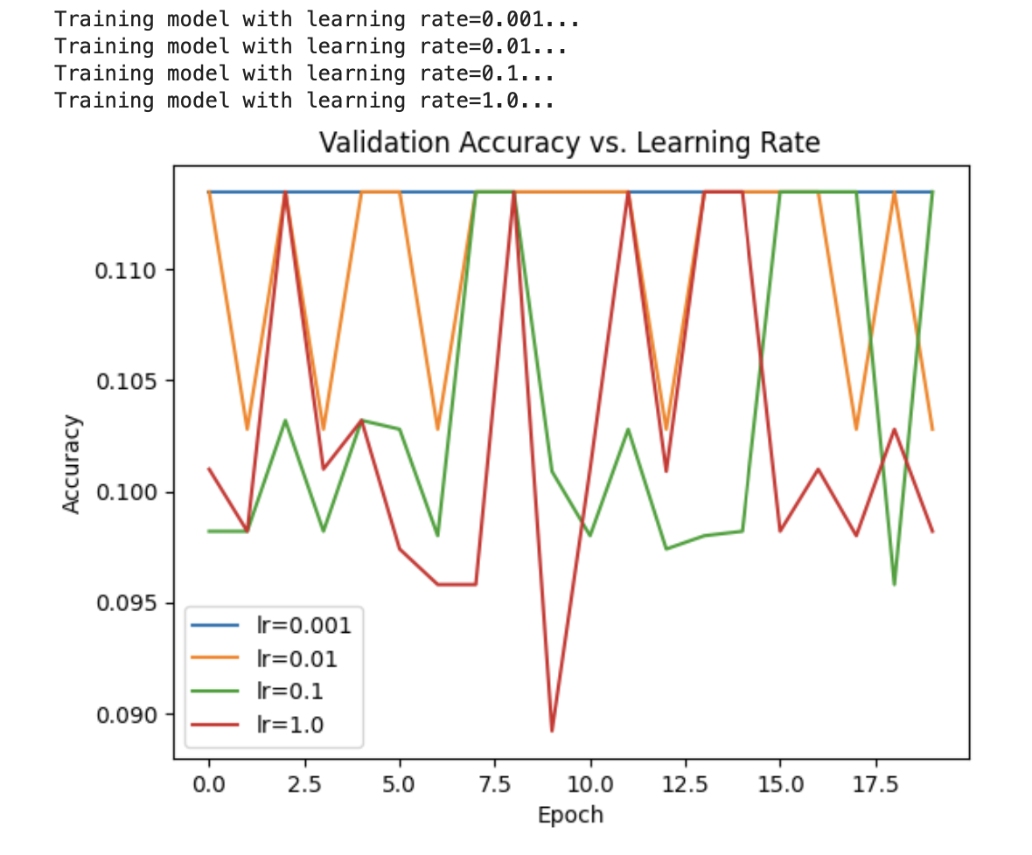

Figure 35

The graph displays the model's validation accuracy for various learning rates across 10 epochs on the handwritten digit dataset. The accuracy of the model starts at roughly 0.96 and steadily risen to about 0.99 over 10 epochs at the lowest learning rate of 0.001. This shows that the model is still developing and might get better with more training epochs.

The model's accuracy begins at roughly 0.96 at the subsequent learning rate of 0.01, and after a few epochs, it reaches its maximum value of about 0.99. The accuracy then stays steady, showing that the model is not continuing to learn much after that. The model's accuracy begins at about 0.96 and soon rises to its peak of about 0.99 within the first hour at the learning rate of 0.1.

# 3d) Was there a case of overfitting observed in your model at any point?

From the training and validation curves plotted earlier, there does not seem to be a case of overfitting in the baseline or modified models. Both models show similar trends in the training and validation accuracy and loss curves, and there is no significant gap between the training and validation accuracies.

However, it's important to note that overfitting can sometimes be difficult to detect just by looking at the curves. It's always a good practice to monitor the performance of the model closely and take steps to prevent overfitting, such as regularization techniques (e.g., dropout, L1/L2 regularization), early stopping, or using more data.

# COMPONENT FOUR

## Abstract

In the past few years, the healthcare industry has fully embraced the use of artificial intelligence to increase diagnosis accuracy and to provide medical services. The rule, policies, and ethics of healthcare practice have been influenced by this movement. In particular, the European Union has decided that AI ought to be trustworthy and centered on people.

## Contributions

### Transparency and People Centric

Artificial intelligence holds great promise for effective, precise, and useful therapeutic and preventive actions. People are also aware of the risks and harm that unchecked advancements in artificial intelligence could cause. Globally, guiding principles are being developed to encourage the trustworthiness of artificial intelligence system development and application.

### Social Acceptance

Using ethics as a chance strategy, actors can benefit from the social advantages of digital technologies. This strikes a balance between any precautionary principle and the duty not to ignore what may and should be done, giving rise to the advantage of being able to recognise and seize fresh chances that are socially acceptable or desirable. Therefore, ethics offers a method for managing risks. A course of action may nevertheless be rejected even if it is legal.

### Developing Trustworthiness into Artificial Intelligence

Therefore, developing trustworthiness into artificial intelligence depends on presumptions about a well-functioning, deliberative democracy and its capacity for governance to steer the advancement of AI-based technologies. The expert panel also emphasised the necessity for an additional sectoral approach to the overall framework and the context-specific character of artificial intelligence. When talking about moral right and wrong, what should be done versus should not be done when making judgements, creating new legal norms, or challenging the status quo, ethical considerations are typically what come to mind.

### Policy Making for Artificial Intelligence

To make sure that healthcare policymakers take wise and trustworthy judgements, it is essential to evaluate the quality, bias risk, and data fusion in trustworthy AI-based healthcare systems. An evaluation of an AI system's effectiveness and precision is referred to as a quality assessment.

Methods like cross-validation and performance evaluation against other models can be used in this. As a result of imbalances in the training data, bias risk refers to the possibility for an AI system to provide unfair or discriminating outcomes. Techniques such as algorithmic fairness and data mining can be used to reduce this risk.

## Gaps

### Data Sharing and Efficiency

More data exchange is needed for widespread AI application in the healthcare industry. For a variety of reasons, including concerns about the security of critical commercial or personal data, some stakeholders are unwilling to share their data with other parties. To better understand big data and AI, healthcare competition and antitrust law will need to change. AI-based models in the healthcare sector can be incredibly beneficial when used to address a big issue. Some issues can be resolved without using AI methods at all because there are workarounds available. If the dataset is very huge, if some or all of the parameters are difficult to forecast, if it takes too long to infer the correct results, or if traditional methods don't work, then these conditions may apply (Pranjal Kumar, Siddhartha Chauhan, Lalit Kumar Awasthi, 2023).

### Multidisciplinary Research Workforce

The advancements in ML/DL techniques have a lot to offer the healthcare sector. To fully benefit from these breakthroughs, however, hurdles like ethical questions must be efficiently overcome. The development of novel ML/DL techniques has been suggested in some study to involve a wide range of interested parties, including physicians, policymakers, data scientists, ML researchers, hospital workers, etc. For example, healthcare service providers will be able to pool their knowledge for the benefit of patient care by bringing clinicians and AI researchers together (Pranjal Kumar, Siddhartha Chauhan, Lalit Kumar Awasthi, 2023).

### Unequal context

A non-universal norm and unequal quality of health care may be sustained by diverse ethical basis for the ethical assessment of appropriate employment of artificial intelligence across national boundaries due to unequal contextual circumstances (Bærøe K, Miyata-Sturm A, Henden E 2020).

## Suggestions

### Ensuring Data Sharing Security

In order to ensure that data are shared or exchanged in AI application in healthcare, there must be a secure protocol for the information exchange to protect personal data or critical information.

### Adherence to Ethical Practices

The policy makers in the healthcare and artificial intelligence must collaborate to ensure that the practitioners follow all the ethical guides while policies are formulated to safeguard the development of AI in healthcare delivery.

### Universal Principle

The basis for ethical assessment globally must be the same for acceptable employment of artificial intelligence in healthcare to ensure standards are adhere to universally.

# REFERENCES:

* A.S. Albahri, Ali M. Duhaim, Mohammed A. Fadhel, Alhamzah Alnoor, Noor S. Baqer, Laith Alzubaidi, O.S. Albahri, A.H. Alamoodi, Jinshuai Bai, Asma Salhi, Jose Santamaría, Chun Ouyang, Ashish Gupta, Yuantong Gu, Muhammet Deveci, A systematic review of trustworthy and explainable artificial intelligence in healthcare: Assessment of quality, bias risk, and data fusion, Information Fusion,Volume 96, 2023,Pages 156-191,ISSN 1566-2535, <https://doi.org/10.1016/j.inffus.2023.03.008.(https://www.sciencedirect.com/science/article/pii/S1566253523000891)>
* Pranjal Kumar, Siddhartha Chauhan, Lalit Kumar Awasthi, Artificial Intelligence in Healthcare: Review, Ethics, Trust Challenges & Future Research Directions, Engineering Applications of Artificial Intelligence, Volume 120, 2023, 105894, ISSN 0952-1976,https://doi.org/10.1016/j.engappai.2023.105894. https://www.sciencedirect.com/science/article/pii/S0952197623000787
* Bærøe K, Miyata-Sturm A, Henden E (2020) How to achieve trustworthy artificial intelligence for health. Bull World Health Organ 98(4):257–262. https://doi.org/10.2471/blt.19.237289 - DOI - PubMed - PMC